**Employee Compensation Forecasting Application   
Links:**

**Local URL**: <http://localhost:8502>

**Network URL**: http://192.168.220.35:8502

**ScreenShots**

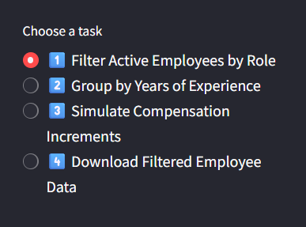

1. 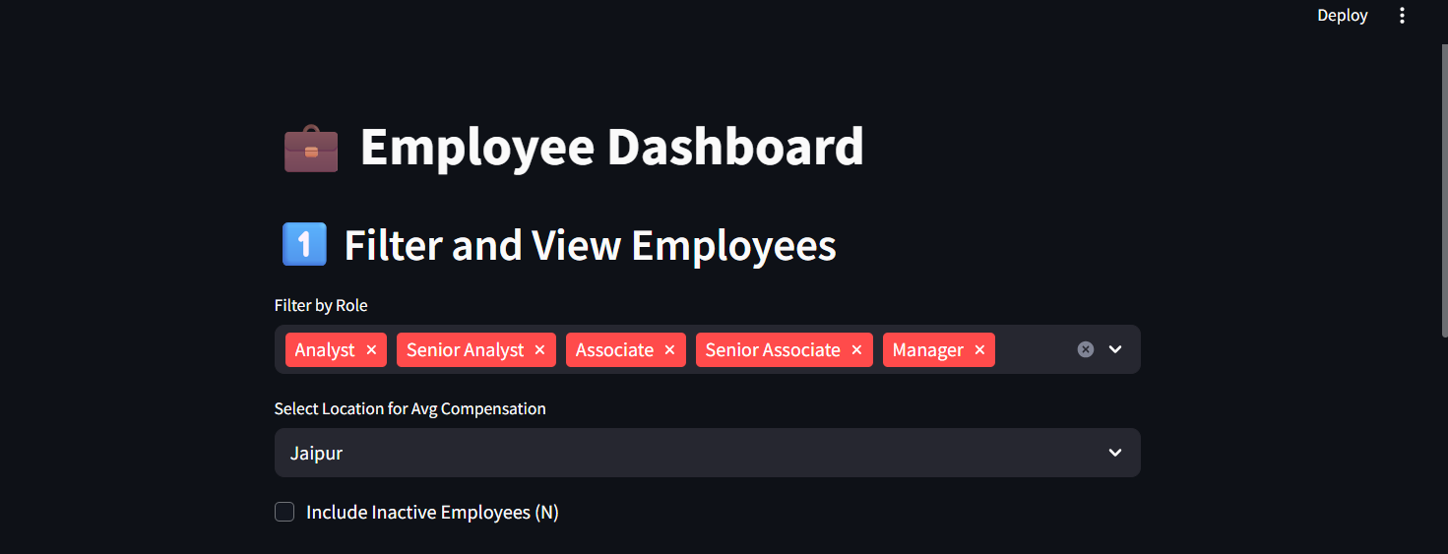**Filter Active Employees by Role**

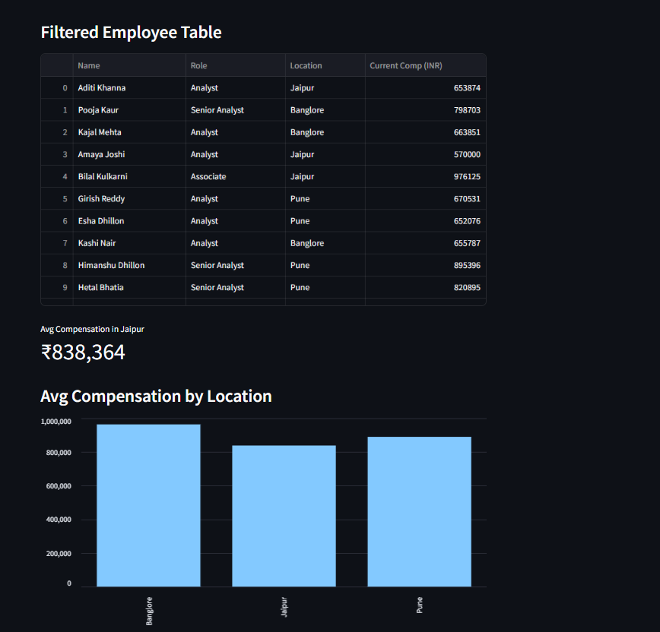

1. **Group by Experience**

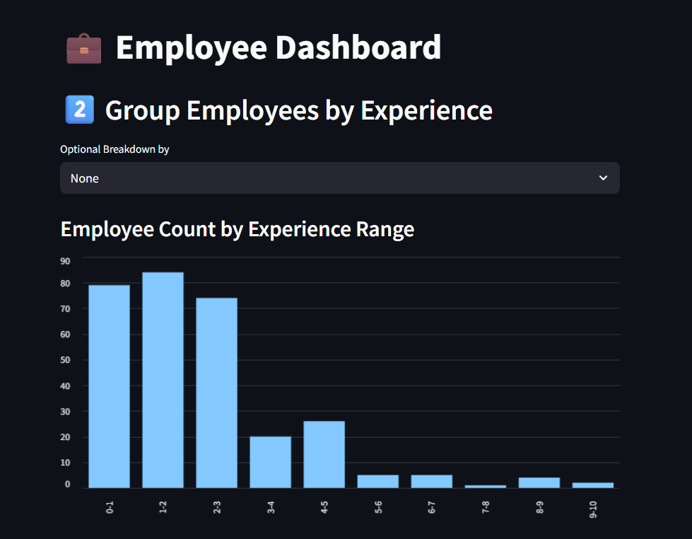

1. 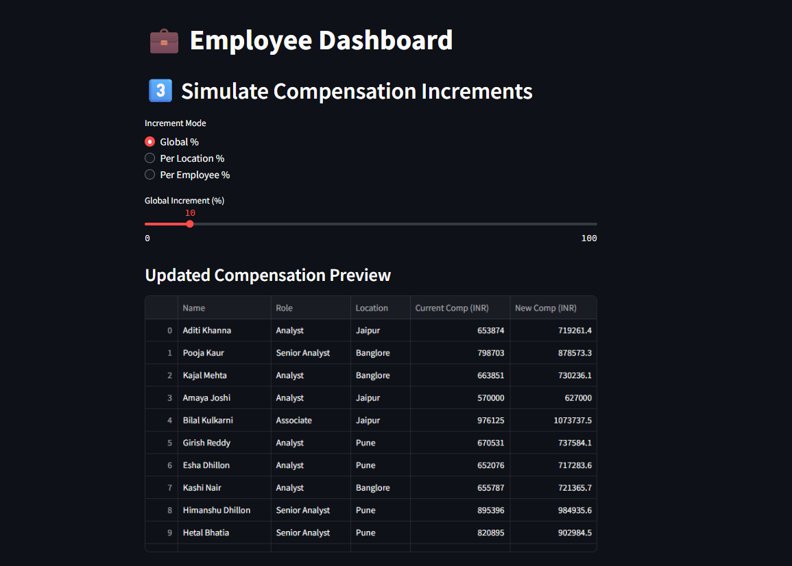**Simulate Compensation Increments**
2. 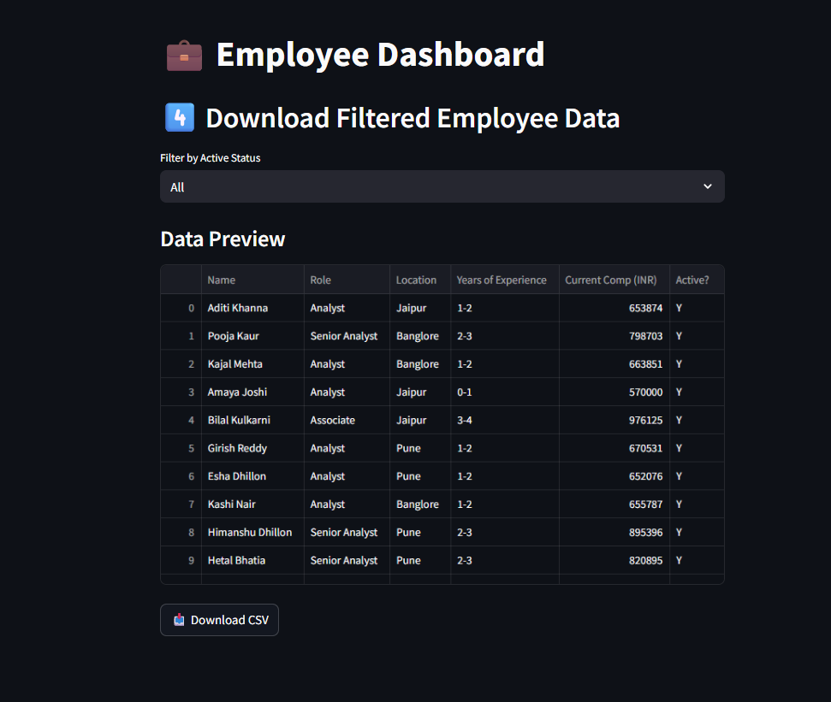**Download Filtered Employee Data**